1) Description of SecureNet: a Cloud Based Smart Home Security Platform:
- SecureNet is a comprehensive cloud-native smart home security and automation platform that provides homeowners with complete control over their home environment through an integrated ecosystem of intelligent IoT devices. SecureNet devices connect directly cloud infrastructure via Wifi, eliminating single points of failure and simplifying installation

High Level Purpose
- The purpose of SecureNet is to solve the fragmentation, reliability, and complexity associated with ununified systems and devices by providing a unified, purpose-built ecosystem where all devices work seamlessly together. The system enables homeowners to monitor their homes in real time, receive instant alerts for important events, control devices remotely, and automate common scenarios, all through a single intuitive interface
accessible via mobile or web applications.

System Goals
- Unified Experience - Provide a single application interface for all home security and automation needs, eliminating the need for multiple apps and accounts
- Reliability - Deliver enterprise grade reliability through cloud native architecture with scalability, load balancing, and automation failover
- Ease of Use - Enable a DIY installation with simple device onboarding (scan QR code, connect to wifi) without requiring professional installation or complex configuration
- Security - Ensure all devices remain secure through automation firmware updates, encrypted communication, and secure cloud infrastructure
- Real-Time Monitoring - Provide homeowners with instant visibility into their homes status with near-instant alert delivery and live video streaming
- Scalability - Support millions of homes and devices globally while maintaining consistent performance
- Device Management - Enable SecureNet operations team to manage the deployed device fleet at scale, push updates efficiently and proactively identify device health issues

2) System Context C4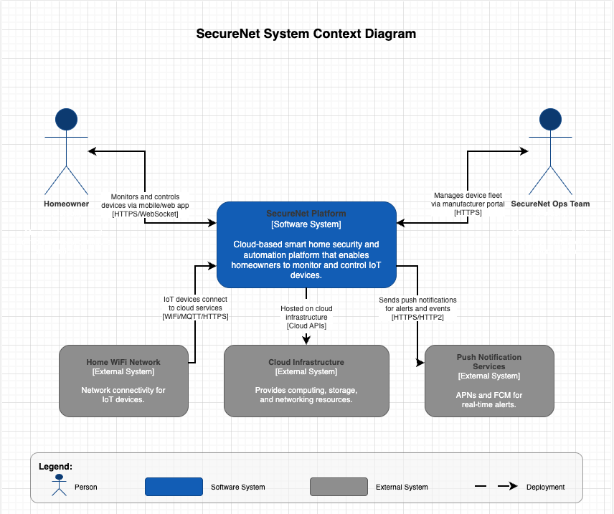
“Figure1: System Context C4” - deprecated

3) System behavior - Happy Path Scenario
How everything behaves when everything works correctly.

Scenario 1: Device Onboarding
- User purchases device
- User downloads app or visits website and creates an account
- Application prompts users to scan device qr code with camera or upload photo of device qr code.
- App accepts qr code and guides user to connect device to wifi and downloads latest firmware
- Device registers with cloud services
- Device then appears in users app dashboard
- Device begins running (ex. Camera begins streaming)

Scenario 2: Motion Detection and Alerts
- Motion Sensor or camera detects movement
- Sensor sends event to cloud
- Event processing service processes the event and evaluates automation rules
- If System determines that an alert should be sent, it then sends a push notification to users phone
- Event is logged in history so user can open app and view either live camera feed or view history to view the event

Scenario 3: Remote Door Lock Control
- User opens application on web or phone while away from home
- User navigates to smart lock device
- User taps/clicks lock
- Command set to cloud services
- Cloud routes command to smart lock device
- Device executes lock command
- Device confirms lock status back to the cloud
- Application updates to show “Locked” status

Scenario 4: Video playback
- User wants to review footage from a certain period of time
- User opens app and selects a camera and navigates to camera history
- User selects time range
- System retrieves archived video data from cloud storage
- Video streams to user device
- User can scrub through timeline

4) System Behavior - Failure Scenarios
How the system handles failures:

Failure 1: Device Loses Wifi Connection
- Camera loses Wifi connectivity
- Device attempts automatic reconnection (with exponential backoff)
- Device continues recording locally to either buffer or local storage
- Device status show offline in app
- When wifi restored, device reconnects
- Buffered/ locally stored footage synced to the cloud
- User receives reconnected notification

Failure 2: Cloud Service Temporarily Unavailable
- API Gateway or backend service goes down
- Devices cache state locally and operate on cached automation rules
- App shows cached devices status with a warning indicator
- User can’t perform remote control operations
- Load balancer routes new requests to healthy service instances
- When service recovers, devices sync state changes
- System logs incident

Failure 3: Insufficient bandwidth for Video Streaming
- User attempts to view live camera feed
- Network bandwidth insufficient for HD stream
- System automatically reduces video quality
- Stream delivered at lower resolution
- When bandwidth improves, quality automatically increases

Failure 4: Device Onboarding Fails
- User attempts to add new device
- QR code scan fails
- App offers manual device ID entry option
- User enters device ID
- Wifi connection fails during setup (wrong password)
- App shows troubleshooting steps
- User retries with correct Wifi password
- Device successfully onboards

Failure 5: Device Becomes Unresponsive
- Smart lock stops responding to commands
- Cloud detects device hasn’t set heartbeat in threshold period
- Device marked as “Unresponsive” in app
- User receives alert notification
- System logs diagnostics information
- Manufacturer portal flags device for investigation
- If device doesn’t recover in 24 hours, user prompted to reset device
- If that doesn’t work contact manufacturer
5) Key System Components
- Web/Mobile Application
- Responsibility: Provide user interface for homeowners to monitor and control devices, configure automation rules, view live/historical video, manage settings
- IoT Device Firmware
- Responsibility: Execute device specific functions (capture video, control locks, detect motion), communicate with cloud, cache automation rules for offline operation, perform local processing
- API Gateway
- Responsibility: Single entry point for all client requests, authentication/authorization, request routing to appropriate backend service, rate limiting, request/response transformation
- Device Management Service
- Responsibility: Device registration and provisioning, maintain device registry, track device connection status, coordinate firmware updates, monitor device health
- Event Processing Service
- Responsibility: Ingest real time events from devices, process event data, route events to appropriate handlers, maintain event history
- Video Streaming Service
- Responsibility: Ingest video streams from cameras, transcode video to multiple formats/bitrates, deliver live streams to clients with adaptive quality, archive video footage
- User Management Service
- Responsibility: User authentication and authorization, manage user profile and preferences, password reset and account recovery
- Notification Service
- Responsibility: Deliver push notifications to mobile devices, manage notification preferences, queue and retry failed notifications
- Data Storage Layer
- Responsibility: Distributed persistent storage for device state, user data, automation rules, event history, video archives, and system configuration with replication for availability

- Removed Manufacturer portal and Automation engine for stage 2

Corrected C4 diagram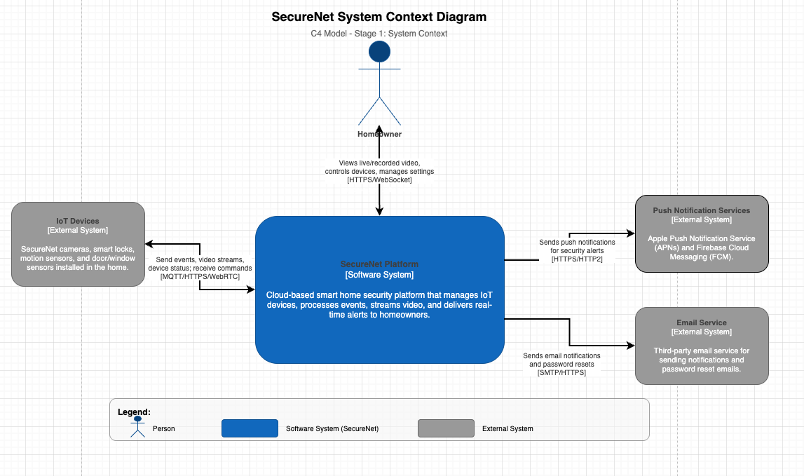
Updated C4 systems context diagram

